A

Project Report On

**CAR RENTAL SYSTEM**

Submitted to

**University of Mumbai**

By

**Mr.Aniket Sunil Dhulap**

**T.Y.B.Sc**.(Computer Science)

Under Guidance Of

**Miss. Samruddhi Sinkar**

Year Duration

**2019-2020**

Throught



**DEPARTMENT OF COMPUTER SCIENCE**

**S. P. HEGSHETYE COLLEGE OF ARTS, COMMERCE AND SCIENCE, RATNAGIRI.**

***(Affiliated to University of Mumbai)***

**RATNAGIRI, 415612**

**S. P. HEGSHETYE COLLEGE OF ARTS, COMMERCE AND SCIENCE, RATNAGIRI.**

***(Affiliated to University of Mumbai)***

**RATNAGIRI**

**MAHARASHTRA**

**415612**

**BACHELOR OF COMPUTER SCIENCE**



**CERTIFICATE**

This is to certify that **MR. ANIKET SUNIL DHULAP** bearing Examination Seat No has successfully completed the project titled ‘**CAR RENTAL SYSTEM**’ for academic year 2019 - 2020 , in partial fulfilment of B.Sc. Degree in Computer Science as prescribed by the University of Mumbai.

**Date :- Place :-**

**Signature :-**

**Project Guide HOD Examiner Principal**

**Acknowledgement**

I would like to thank to **“Navnirman Shikshan Society”** who gave me the information of the entire workout of their present system.

I would especially thank **Miss. Samruddhi Sinkar** and all teaching and non-teaching staff of Computer Science faculty who inspiring me in completion of project.

I am thankful to **Prof. Miss. Ruhina Mayer** madam Head of Department of computer science department for their timely help and guidance in completing this project successfully.

I would also like to express our deep regards and gratitude to ourPrincipal **Mr. Sawant** sir for his support and **Mr. Bhagwan Mukadam** sir for facilities provided to us for the same.

Lastly, I would like to thank all those who directly and indirectly helped in completion of this project.

Thanking You

Mr.Aniket Sunil Dhulap.

**S. P. HEGSHETYE COLLEGE OF ARTS, COMMERCE AND SCIENCE, RATNAGIRI.**

**MAHARASHTRA**

**415612**



DECLARATION

I here by declare that the project entitled, **“Car Rental System”** done at **place where** **the project is done**, has not been in any case duplicated to submit to any other university for the award of any degree. To the best of my knowledge other than me, no one has submitted to any other university.

The project is done in partial fulfillment of the requirements for the award of degree of **BACHELOR OF SCIENCE (COMPUTER SCIENCE)** to be submitted as final semester project as part of our curriculum.

Mr.Aniket Sunil Dhulap

**Plagiarism Report**

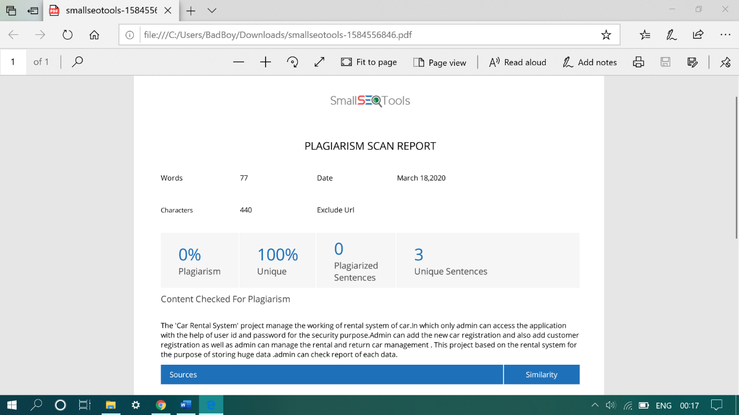

**INDEX**

|  |  |
| --- | --- |
| Sr . No | Topics |
| 1 | **Title-Introduction** |
| 2 | **Module** |
|  | * **Admin Module** |
| 3 | **Abstract** |
| 4 | **Requirement Analysis** |
|  | * **Software Requirement** |
|  | * **Hardware Requirement** |
| 5 | **Feasibility Reports** |
|  | * **Existing System** |
|  | * **Proposed System** |
|  | **-** **Feasibility Study** |
| 6 | **Objective** |
| 7 | **Drawback** |
| 8 | **Gantt Chart** |
| 9 | **System Design** |
|  | * **Module Design** |
| 10 | **Design** |
| 11 | **Data Dictionary** |
|  | **Use Case Diagram - Car Registration** |
|  | * **Customer Registration** |
|  | * **Rentals And Returns** |
| 12 | **Activity Diagram** |
|  | * **Car and Customer Details Modification** |
|  | * **Rent and Return Car** |
|  | * **Add a New Car** |
|  | * **View Reports** |
| 13 | **ER Diagram** |
| 14 | **Source Code** |
| 15 | **Screenshots** |
| 16 | **Conclusion and Scope** |

**Title**

“Car Rental System”

**Introduction:-**

* Car Rental System is offline management system which is used to management works in the rental system of car, I am explaining various functionality of Car Rental System.
* We developed this project to book a car on rent at the fare charges. In present system all booking work done manually and it takes very hard work to maintain the information of booking and cars. If you want to find which vehicle is available for booking then it takes a lot of time. It only makes the process more difficult and hard.
* **Car Rental System project is a desktop application which is developed in C# .NET platform.**
* This project is designed so as to be used by Car Rental Company specializing in renting cars to customers.
* A registration portal to hold customer’s details, monitor their transaction and used same to offer better and improve services to them.
* A car rental is a vehicle that can be used temporarily for a fee during a specified period. Getting a rental car helps people get around despite the fact they do not have access to their own personal vehicle or don't own a vehicle at all.
* This system increases customer retention and simplify vehicle and staff management.
* This Car Rental System project will enable the user to rent a vehicle.

**Module**

* **Admin module:-**
* Manage working of all .
* It is the most powerful user of the system
* Admin can register the new customer.
* Admin can register new car.
* Also admin can handle the rental and return working of car.
* Manage car information.
* See reports of car registration , customer registration , rental data and return car data.

**Abstract**

* The purpose of the project entitled as “ **CAR RENTAL SYSTEM** ” is to computerize the Front Office Management of Rental System to develop software which is user friendly simple, fast, and cost – effective.
* It deals with the collection of cars , customers , rentals , returns car. Traditionally, it was done manually.
* A car rental is a vehicle that can be used temporarily for a fee during a specified period. Getting a rental car helps people get around despite the fact they do not have access to their own personal vehicle or don't own a vehicle at all.
* This system increases customer retention and simplify vehicle and staff management.

**Requirement Analysis**

* **Software Requirements**
* Software :- Visual Studio 2010 - Visual Studio 2012
* Front End :- ASP.NET
* Back End :- Microsoft SQL server 2008 to 2012
* Language :- C#
* Operating System :- Windows 7 to Windows 10
* **Hardware Requirements**
* RAM :- 2GB RAM
* Processor :- i3
* Hard Disk :- 50 GB

* **The above specified requirements are the minimum required to run the application**

**Feasibility Reports**

* **Existing System:-**
* Car Rental currently use a manual system for the management and maintainance of critical information. The current system requires numerous paper forms, with data stores spread through out the car rental management infrastructure. Often information is incomplete or does not follow management standards. Forms are often lost in transit between departments requiring a comprehensive auditing process to ensure that no vital information is lost. Multiple copies of the same information exist in the hospital and may lead to inconsistencies in data in various data stores.
* **Proposed System:**
* The Car Rental System is designed for any Rental System to replace their existing manual paper based system. The new system is to control the information of cars customers , Car availability . These services are to be provided in an efficient, cost effective manner, with the goal of reducing the time and resources currently required for such tasks .
* The proposed system has enhanced features, which was not found in the existing system.
* Security for the data is done easily.
* Validation is done to enter correct data.
* Memory consumption is very less and the processing speedis fast.
* Data reports are presented in a neat format.
* **Feasibility Study:**
* The feasibility of the project is analysed in this phase and business proposal is put forth with a very general plan for the project and some cost estimates. During system analysis the feasibility study of the proposed system is to be carried out. This is to ensure that the proposed system is not a burden to the company. For feasibility analysis, some understanding of the major requirements for the system is essential.

**Objective**

Some Companies currently use a manual system for the management and maintenance of critical information. The current system requires numerous paper forms, with data stores spread throughout the Car Rental management infrastructure. Often information (on forms) is incomplete, or does not follow management standards. Forms are often lost in transit between departments requiring a comprehensive auditing process to ensure that no vital information is lost. Multiple copies of the same information exist in the hospital and may lead to inconsistencies in data in various data stores.

* **Computerization** –
* All the details regarding rentals, whether it is small or big, will be computerised.

* **Keep the Records** –
  + - It will be easier task for the management to keep the record of the all rental and returns car.

**Drawbacks**

* The existing system is manual system.
* Needs to be converted into automated system.
* Risk of mismanagement of data.
* Less security.
* No proper coordination between different Applications and users.
* Accuracy not guaranteed.
* Reports are generated manually.
* Take lot of time.

**Gantt Chart**

|  |  |  |  |  |  |  |
| --- | --- | --- | --- | --- | --- | --- |
| **Month** | **Oct**  **Week1-2** | **Nov**  **Week 2-4** | **Dec**  **Week 1-2** | **Jan Week 2-4** | **Feb**  **Week**  **1-2** | **Mar**  **Week**  **4** |

**Investigation Expected time :-**

**Actual time :-**

**Analysis**

**Design**

**Program**

**Coding**

**Implementation**

**Project**

**Submission**

8 16 24 31 7 14 21 28 4 11 18 26 2 12 18 24 30 3 10 16 25 30 4 14 24 30 4 10 18 25

7 7 7 7 8 8 8 8 9 9 9 9 10 10 10 10 10 11 11 11 11 11 12 12 12 12 1 1 1 1

**System Design**

* **Administration:**

This module handles all the master entry details for the rental and returns requirement such as register new car , register new customer , manage rental system , manage returns car system

As well as admin can check all Reports.

* All controls of system.
* Car and Customer registration.
* Rental and return car management.
* View reports.
* **Module Design:-**
* The importance can be stated with a single word “Quality”. Design is the place where quality is fostered in software development. Design provides us with representations of software that can assess for quality. Design is the only way that we can accurately translate a customer’s view into a finished software product or system

**Design**

                      Design is the first step in the development phase for any techniques and principles for the purpose of defining a device, a process or system in sufficient detail to permit its physical realization.

                      Once the software requirements have been analyzed and specified the software design involves three technical activities - design, coding, implementation and testing that are required to build and verify the software.

                      The design activities are of main importance in this phase, because in this activity, decisions ultimately affecting the success of the software implementation and its ease of maintenance are made. These decisions have the final bearing upon reliability and maintainability of the system. Design is the only way to accurately translate the customer’s requirements into finished software or a system.

Design is the place where quality is fostered in development. Software design is a process through which requirements are translated into a representation of software. Software design is conducted in two steps. Preliminary design is concerned with the transformation of requirements into data.

**Data Dictionary**

**dbo.carreg :-**

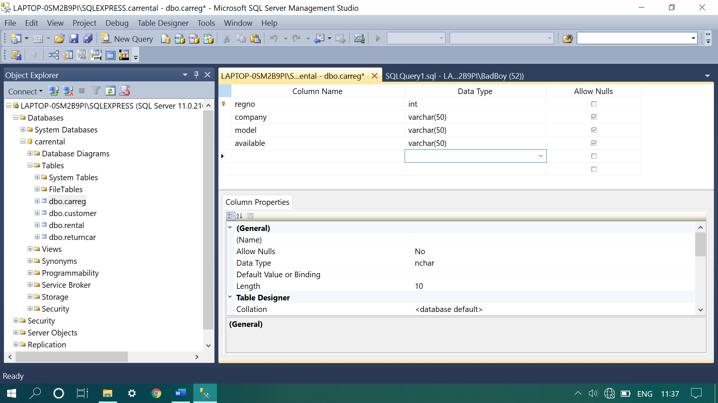

**dbo.customer :-**

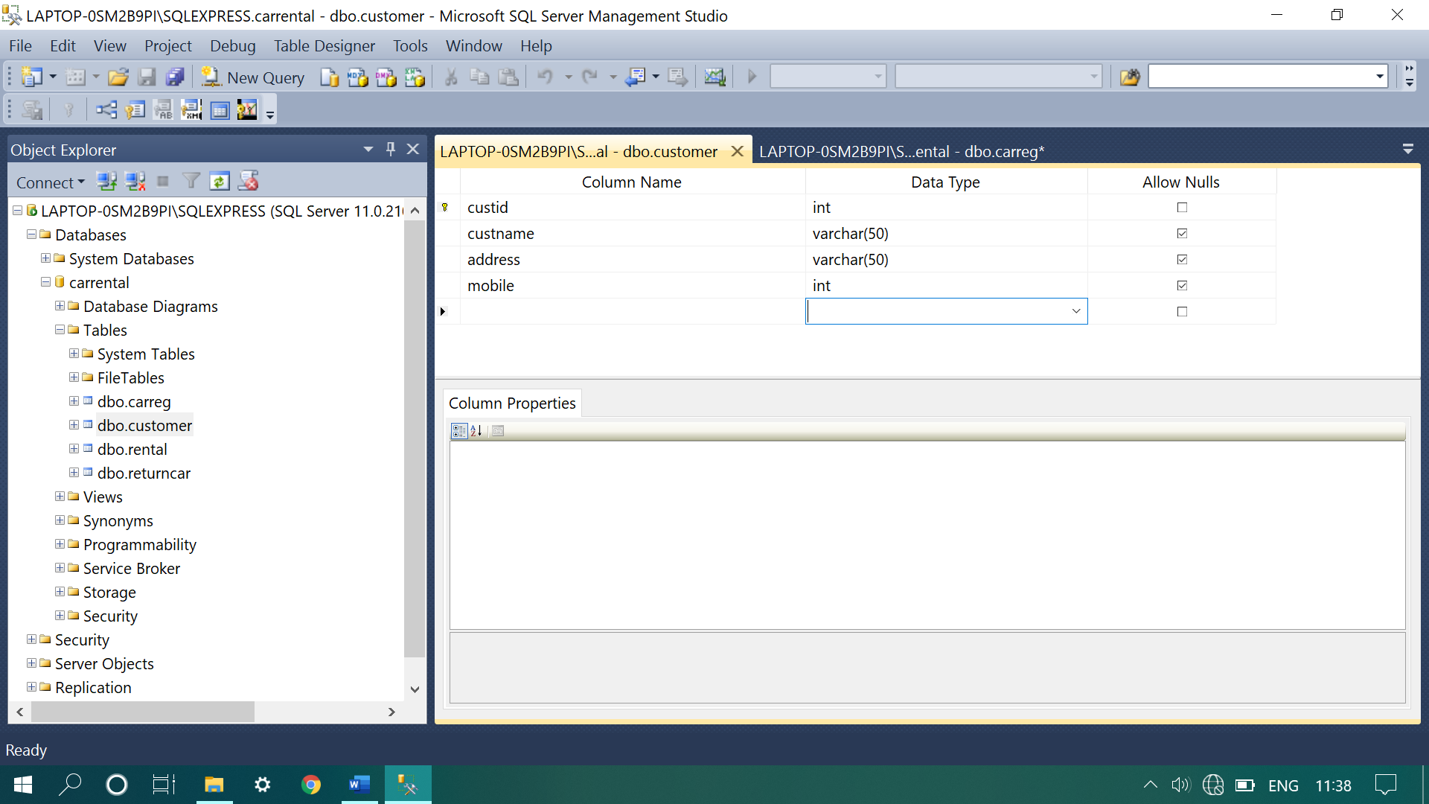

**dbo.rental :-**

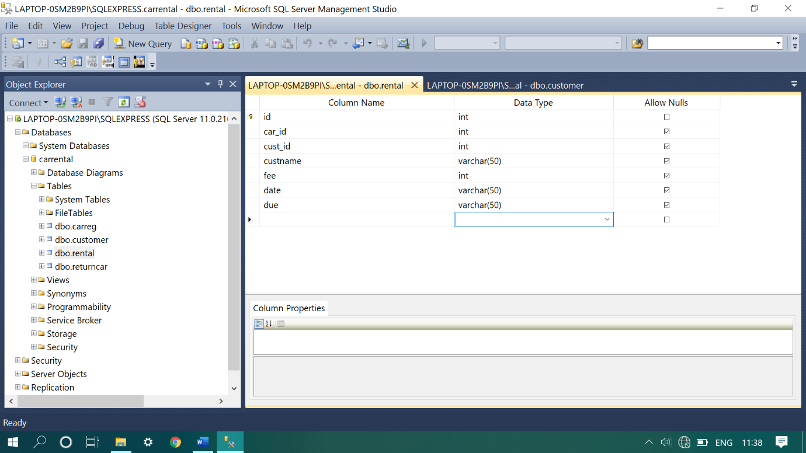

**dbo.returncar :-**

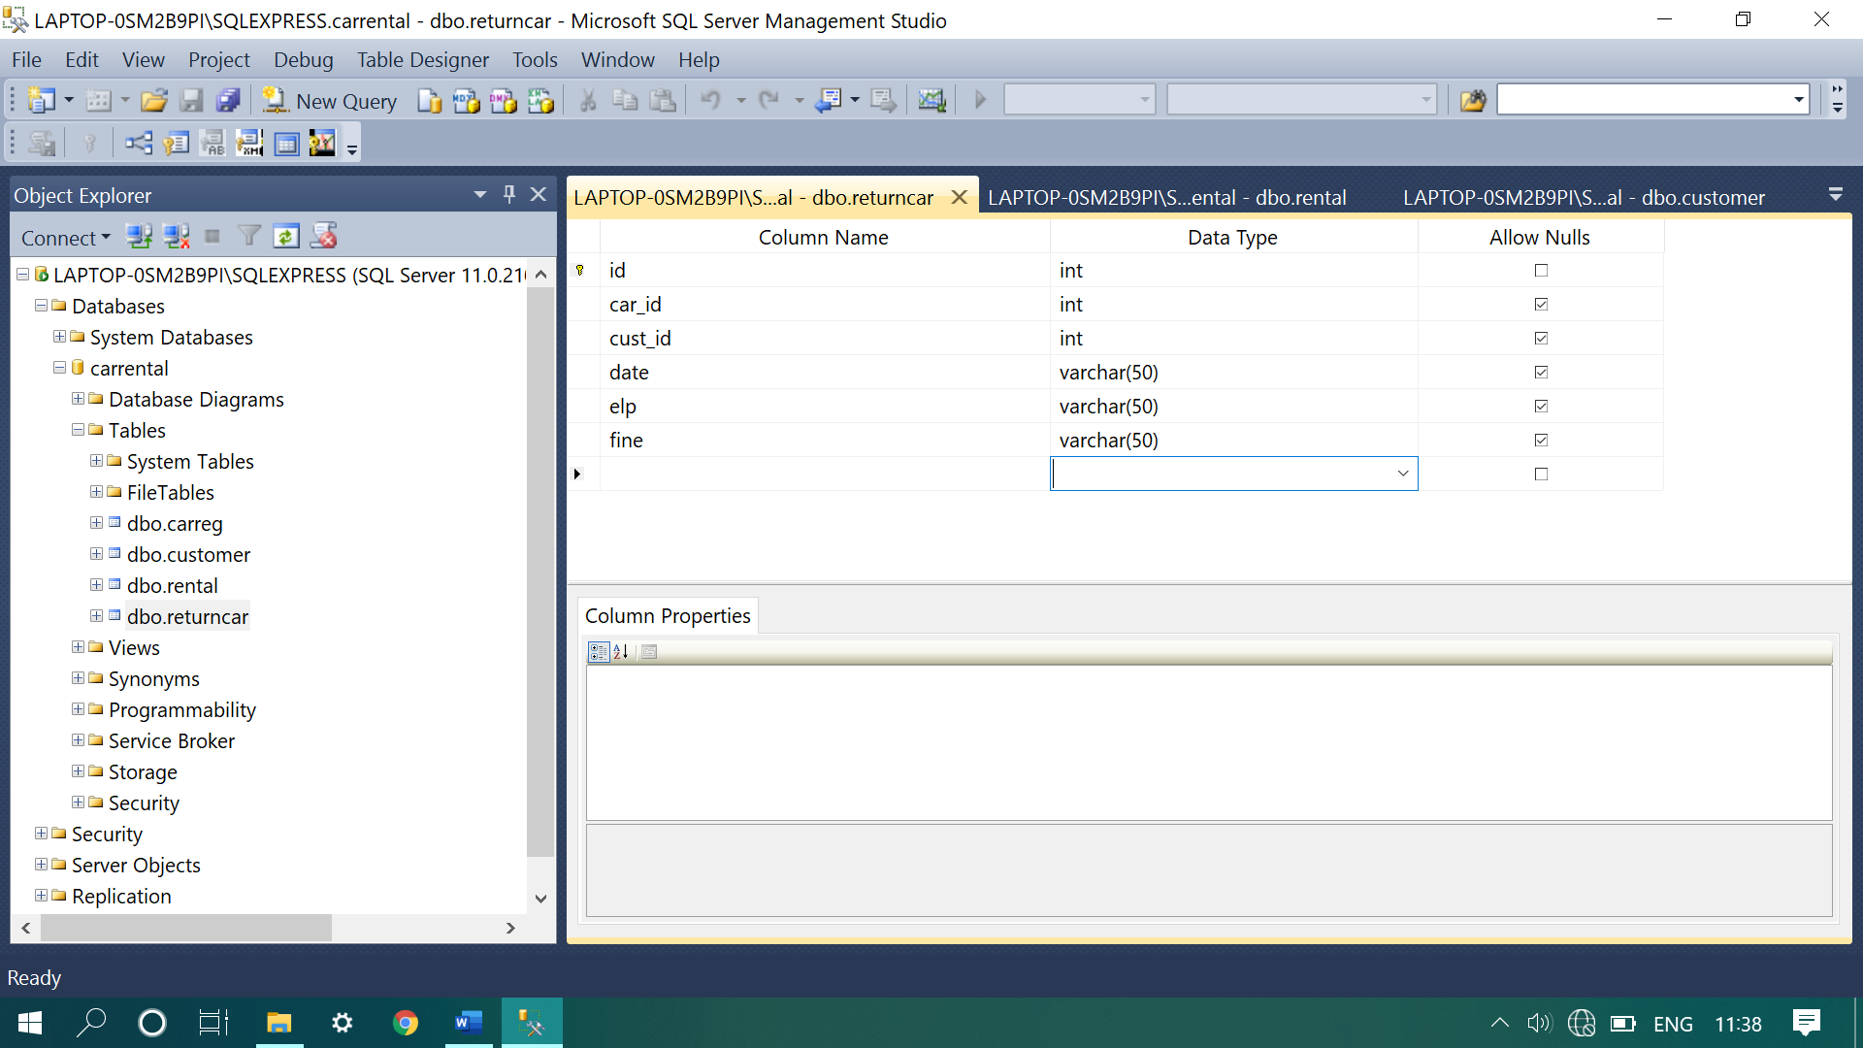

**Use Case Diagram**

**Car Registration:-**

Admin

**Customer Registration:-**

Admin

**Rental and Return:**

Customer

Admin

**Activity Diagram**

Activity diagrams graphically represent the sequential business and operational workflows of a system. It is a dynamic diagram that shows the activity and the event that causes the object to be in the particular state. The workflows from activity diagram will serve as guide for system navigation in the final design phase of the system.

**Car and Customer Details Modification:-**

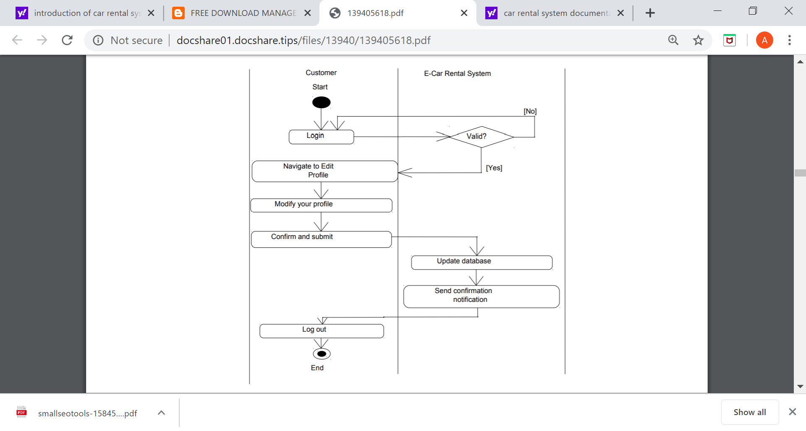

Edit Cust Details

Edit Car Details

Admin

refresh

Car And Customer

**Rent And Return Car:-**

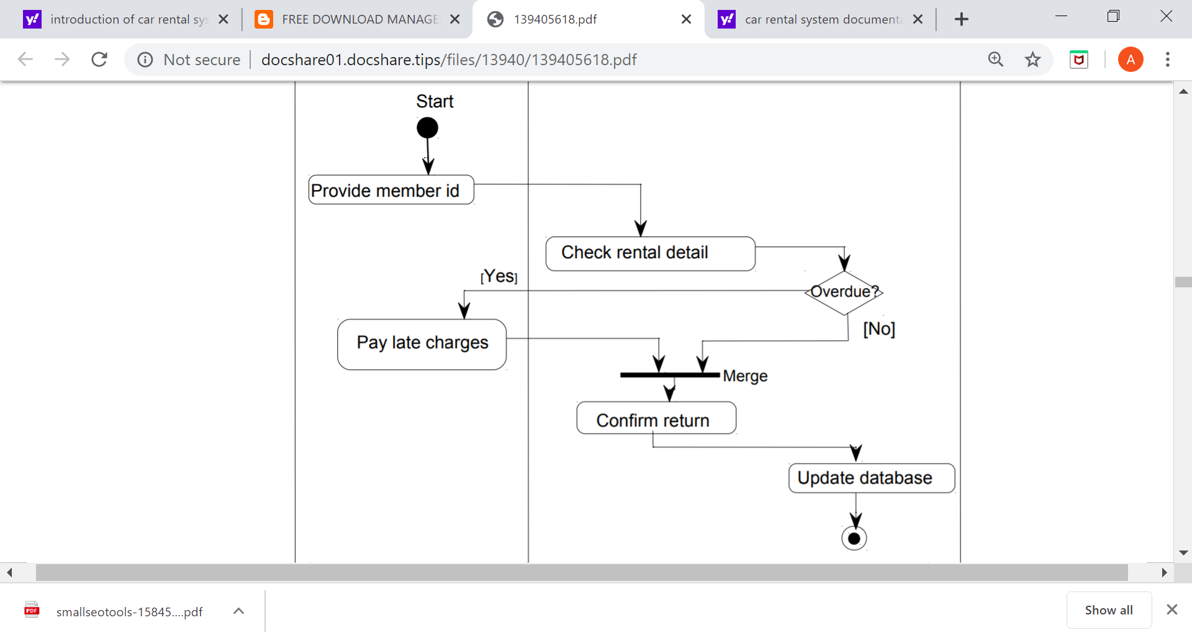

Admin

**Add a new Car:-**

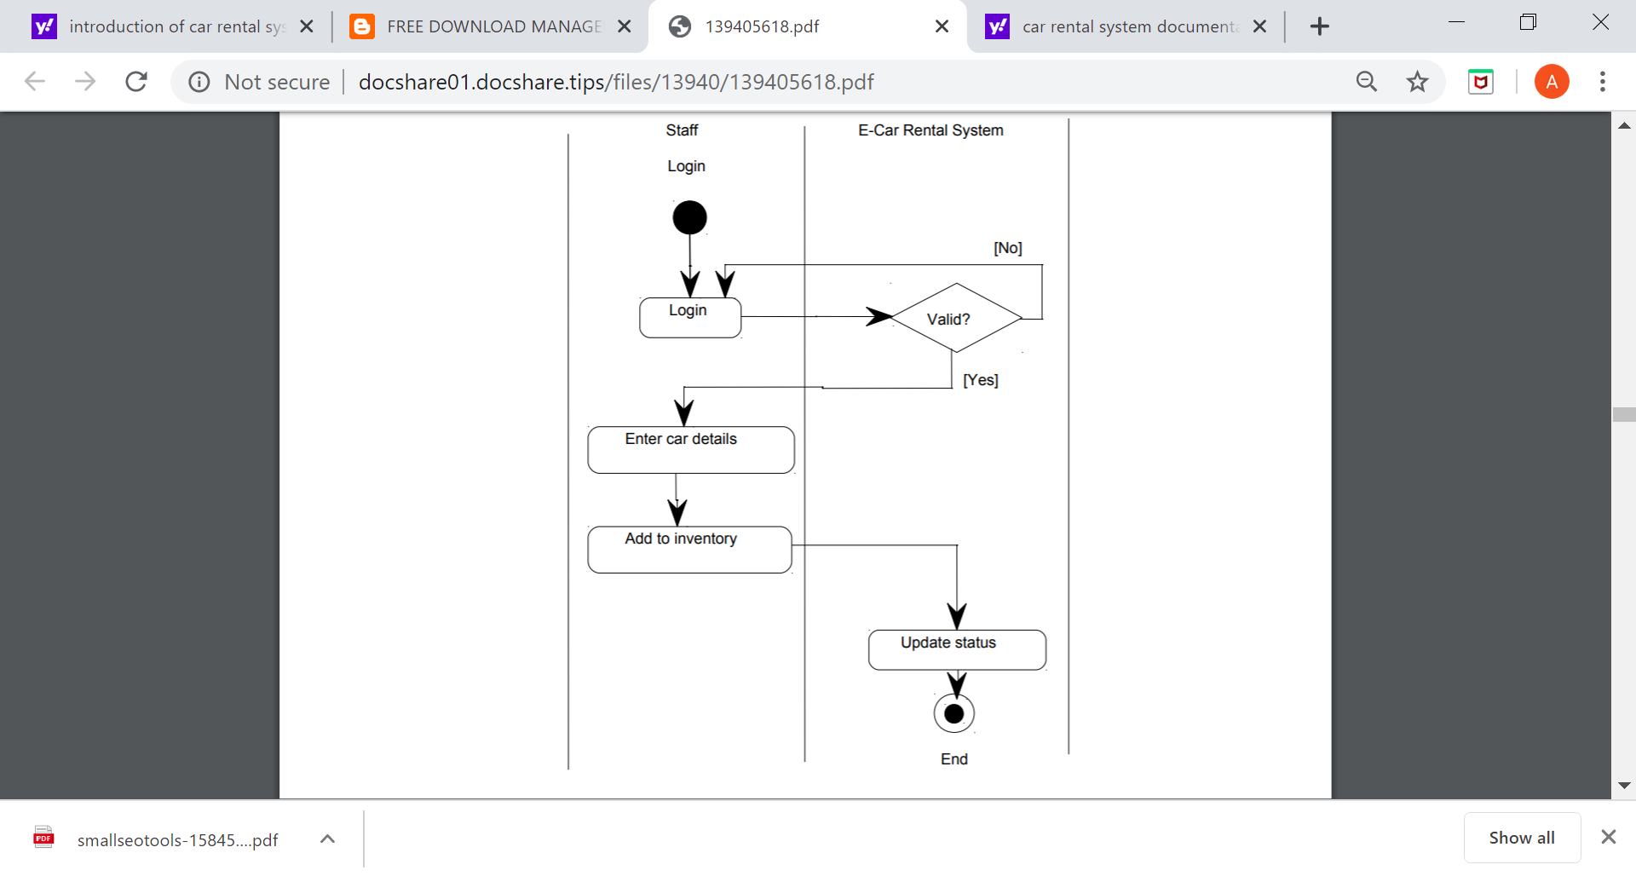

Admin

**View Reports:-**

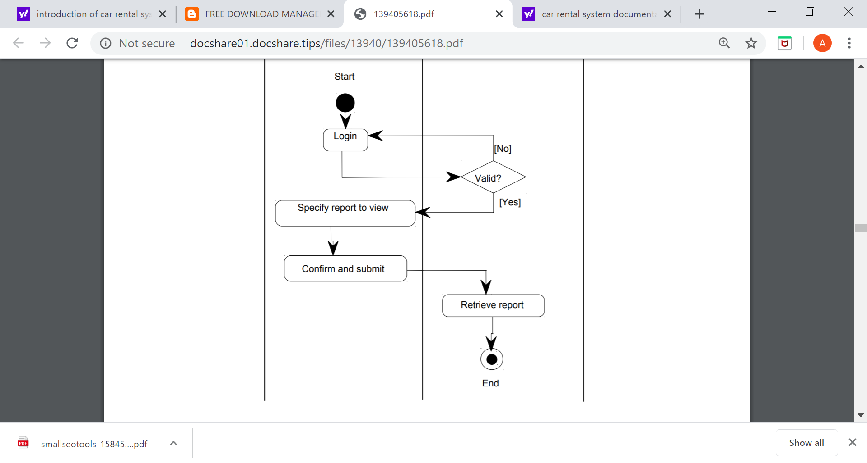

Admin

**E-R Diagram**

**Admin:-**

**Cust Registration**

**Car Registration**

**Admin**

**Rental**

**Return Car**

**Source Code**

**Front Page:-**

using System;

using System.Collections.Generic;

using System.ComponentModel;

using System.Data;

using System.Drawing;

using System.Linq;

using System.Text;

using System.Threading.Tasks;

using System.Windows.Forms;

namespace carrental

{

public partial class Form1 : Form

{

public Form1()

{

InitializeComponent();

}

private void button1_Click(object sender, EventArgs e)

{

if (txtuname.Text == "Admin" && txtpass.Text == "Pass")

{

button3.Enabled = true;

button4.Enabled = true;

button5.Enabled = true;

button6.Enabled = true;

button11.Enabled = true;

button8.Enabled = true;

button9.Enabled = true;

button10.Enabled = true;

button7.Enabled = true;

txtuname.Clear();

txtpass.Clear();

}

else

{

MessageBox.Show("Please Enter correct Login details", "Car Rental System");

txtuname.Clear();

txtpass.Clear();

txtuname.Focus();

}

}

private void button3_Click(object sender, EventArgs e)

{

carreg a = new carreg();

a.Show();

}

private void button4_Click(object sender, EventArgs e)

{

customer b = new customer();

b.Show();

}

private void button5_Click(object sender, EventArgs e)

{

rental c = new rental();

c.Show();

}

private void button6_Click(object sender, EventArgs e)

{

returncar d = new returncar();

d.Show();

}

private void txtuname_TextChanged(object sender, EventArgs e)

{ }

private void button8_Click_1(object sender, EventArgs e)

{

crystalcustomer r = new crystalcustomer();

r.Show();

}

private void button9_Click(object sender, EventArgs e)

{

crystalrental m = new crystalrental();

m.Show();

}

private void button10_Click(object sender, EventArgs e)

{

crystalreturn cr = new crystalreturn();

cr.Show();

}

private void button11_Click(object sender, EventArgs e)

{

crystalcar f = new crystalcar();

f.Show();

}

private void Form1_Load(object sender, EventArgs e)

{

button3.Enabled = false;

button4.Enabled = false;

button5.Enabled = false;

button6.Enabled = false;

button11.Enabled = false;

button8.Enabled = false;

button9.Enabled = false;

button7.Enabled = false;

button10.Enabled = false;

}

private void button7_Click(object sender, EventArgs e)

{

DialogResult iExit;

iExit = MessageBox.Show("Are you sure want to Logout ?", "Car Rental System", MessageBoxButtons.YesNo, MessageBoxIcon.Question);

if (iExit == DialogResult.Yes)

{

txtuname.Clear();

txtpass.Clear();

txtuname.Focus();

button3.Enabled = false;

button4.Enabled = false;

button5.Enabled = false;

button6.Enabled = false;

button11.Enabled = false;

button8.Enabled = false;

button9.Enabled = false;

button10.Enabled = false;

button7.Enabled = false;

}

}

private void button2_Click(object sender, EventArgs e)

{

txtuname.Clear();

txtpass.Clear();

txtuname.Focus();

}

private void btnMinimise_Click(object sender, EventArgs e)

{

this.WindowState = FormWindowState.Minimized;

}

private void btnX_Click(object sender, EventArgs e)

{

DialogResult iExit;

iExit = MessageBox.Show("Confirm if you want close", "Car Rental System", MessageBoxButtons.YesNo, MessageBoxIcon.Question);

if (iExit == DialogResult.Yes)

{

this.Close();

}

}

}

}

**Screenshots**

**Home Page Design:-**

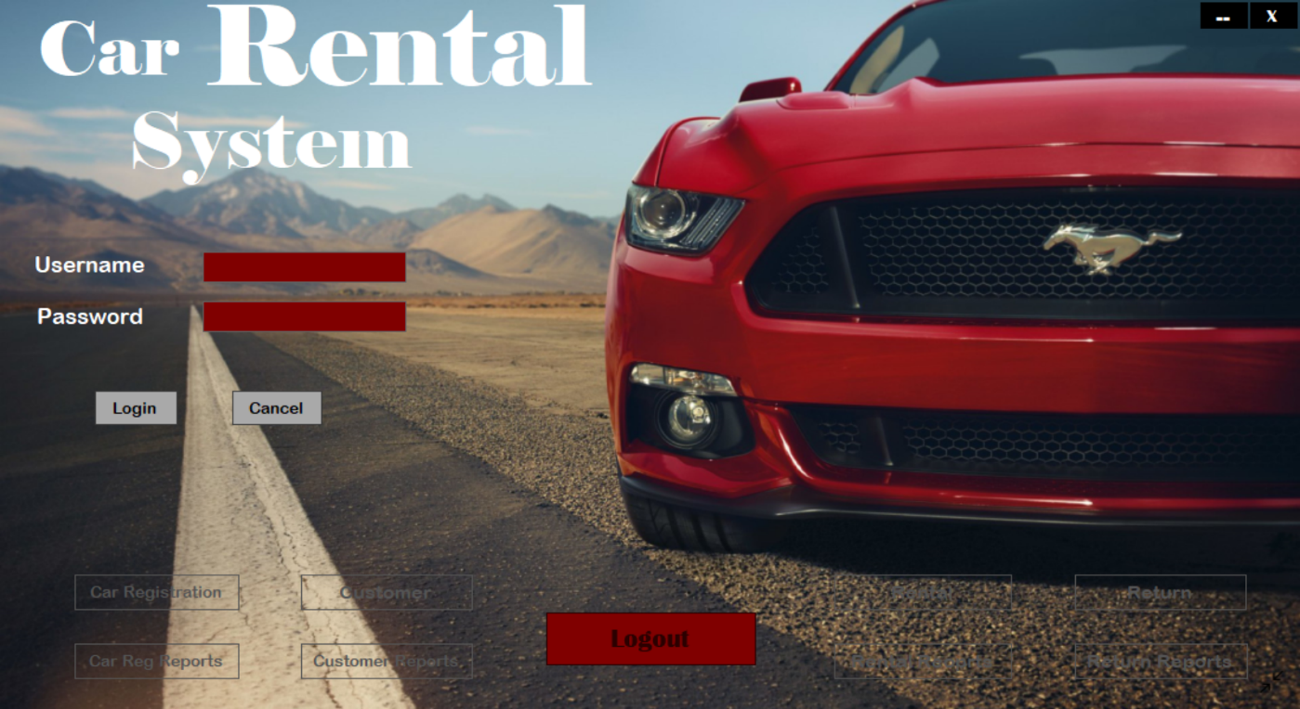

**After Login Home Page :-**

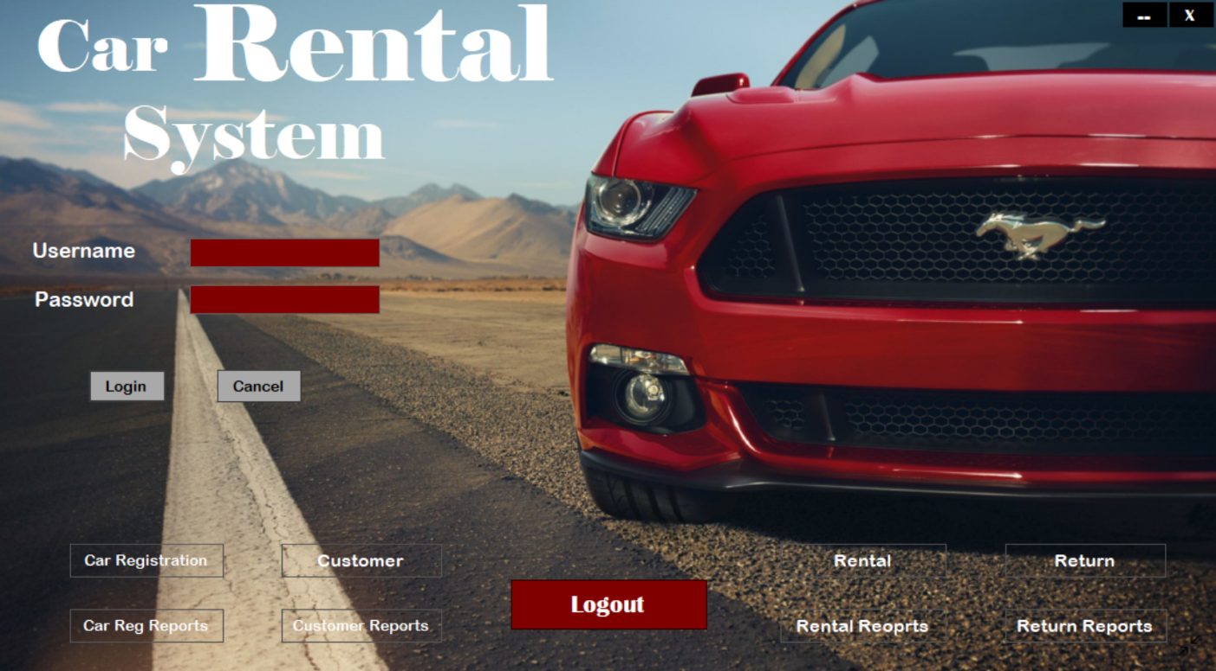

**Car Registration Form :-**

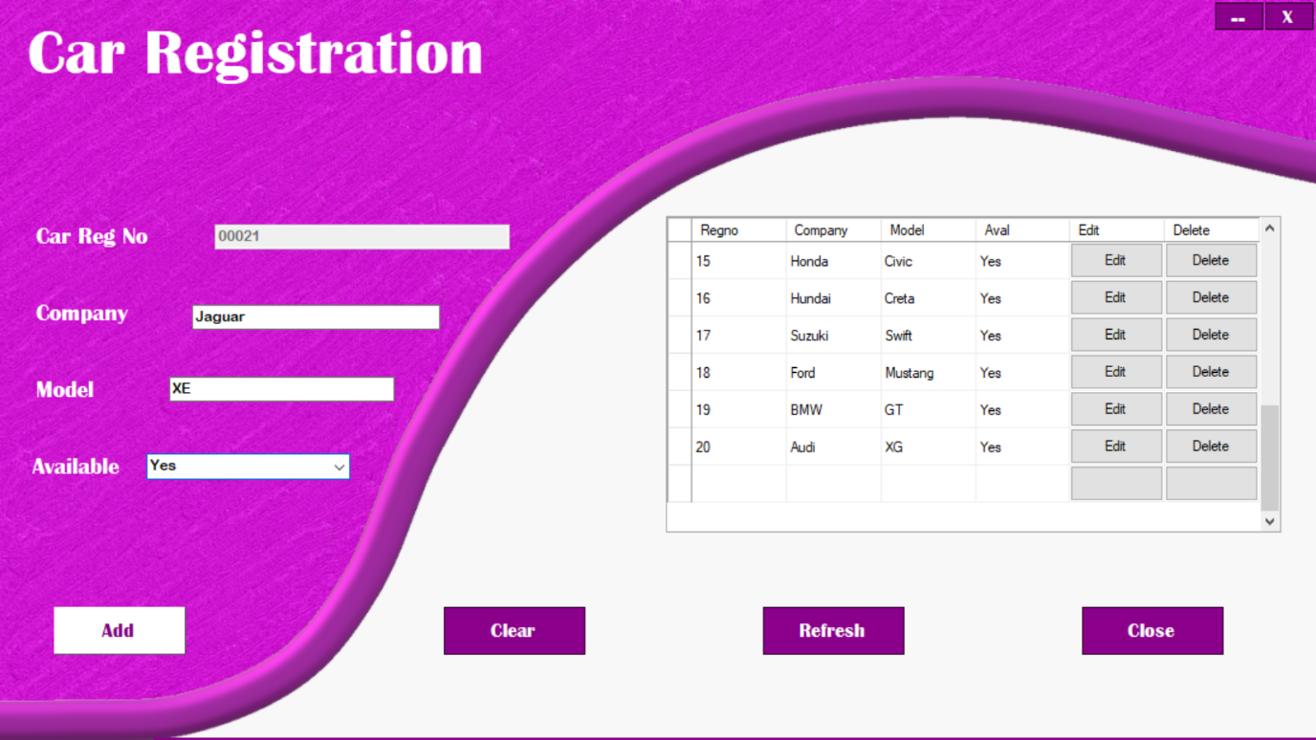

**Car Registration Reports :-**

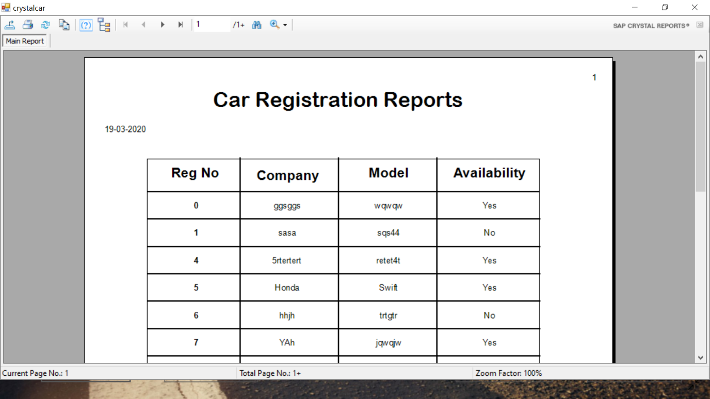

**Customer Registration Form :-**

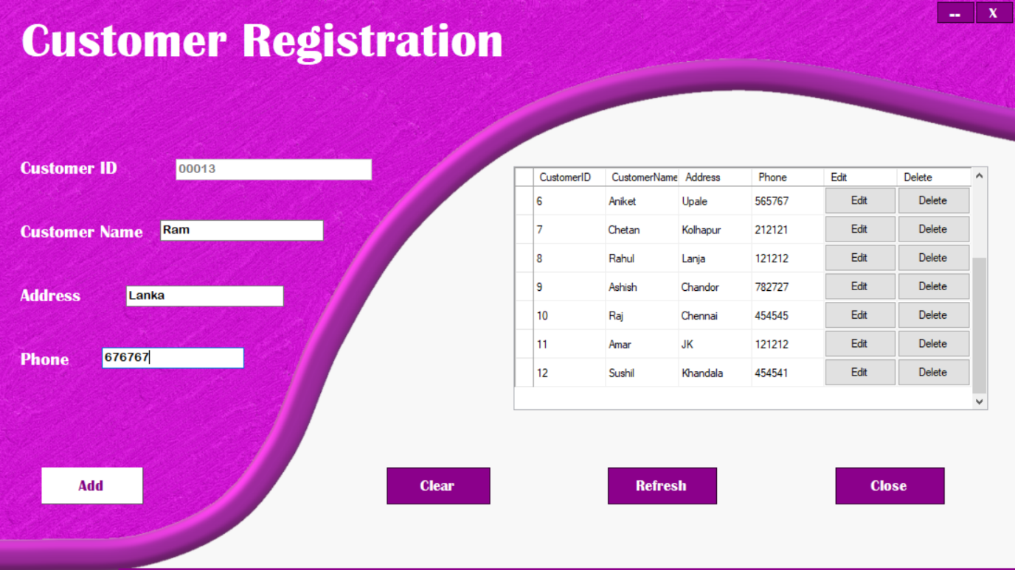

**Customer Registration Reports :-**

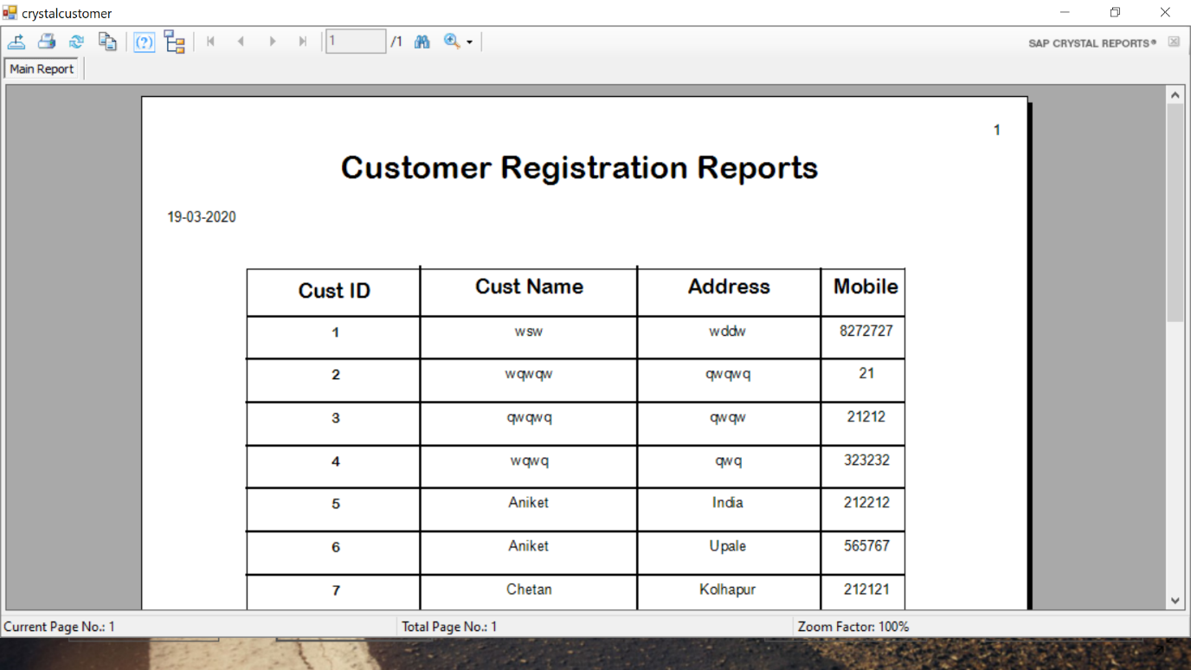

**Rental Form :-**

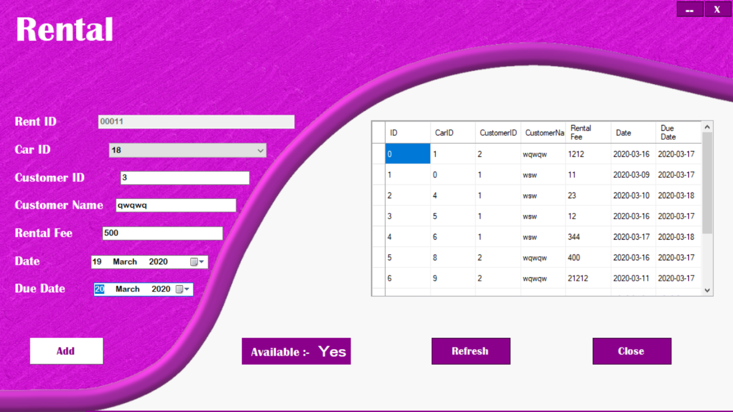

**Rental Reports :-**

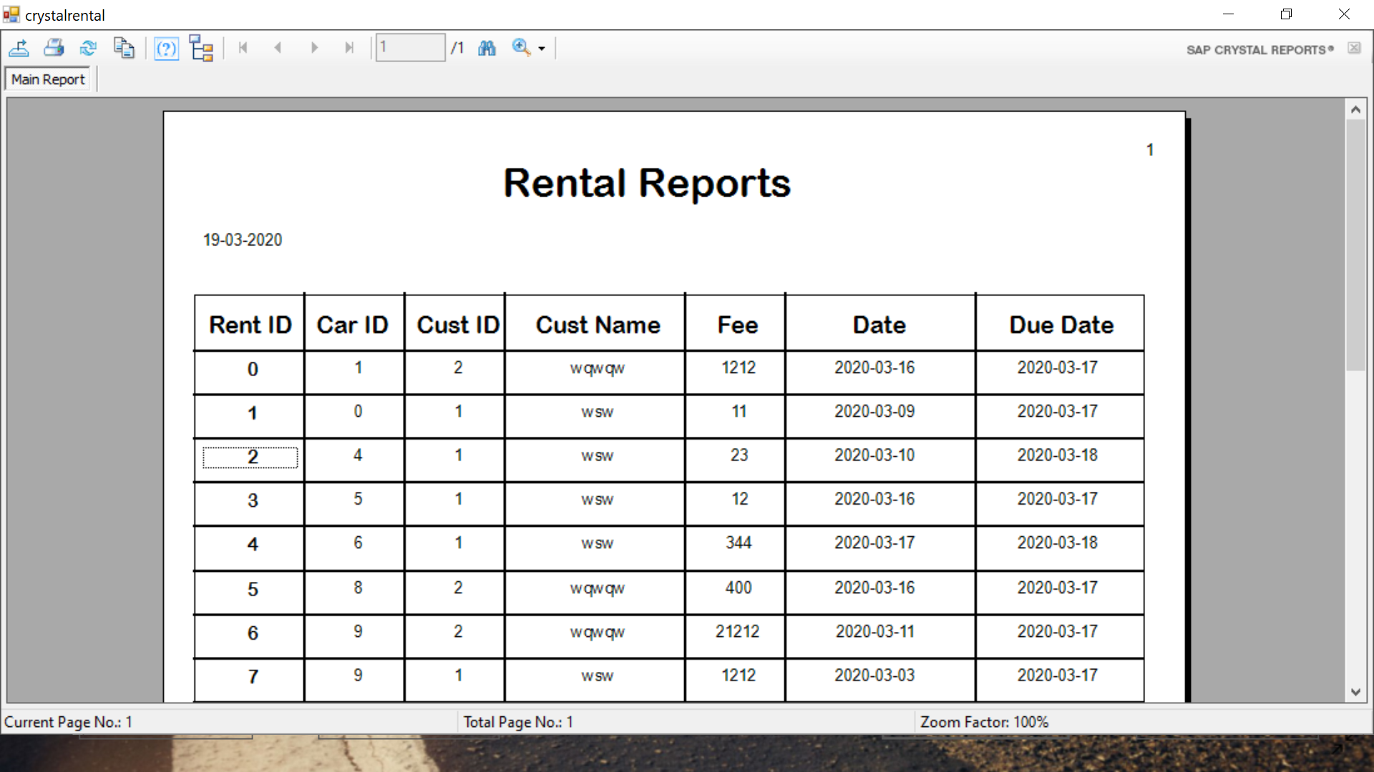

**Return Car Form :-**

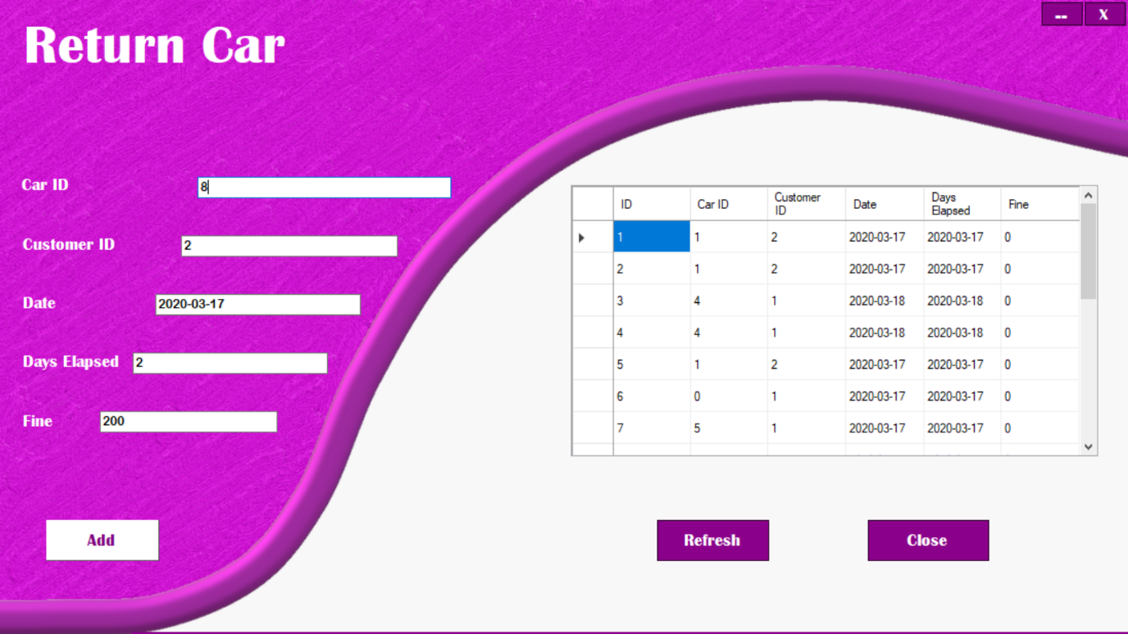

**Return Car Reports :-**

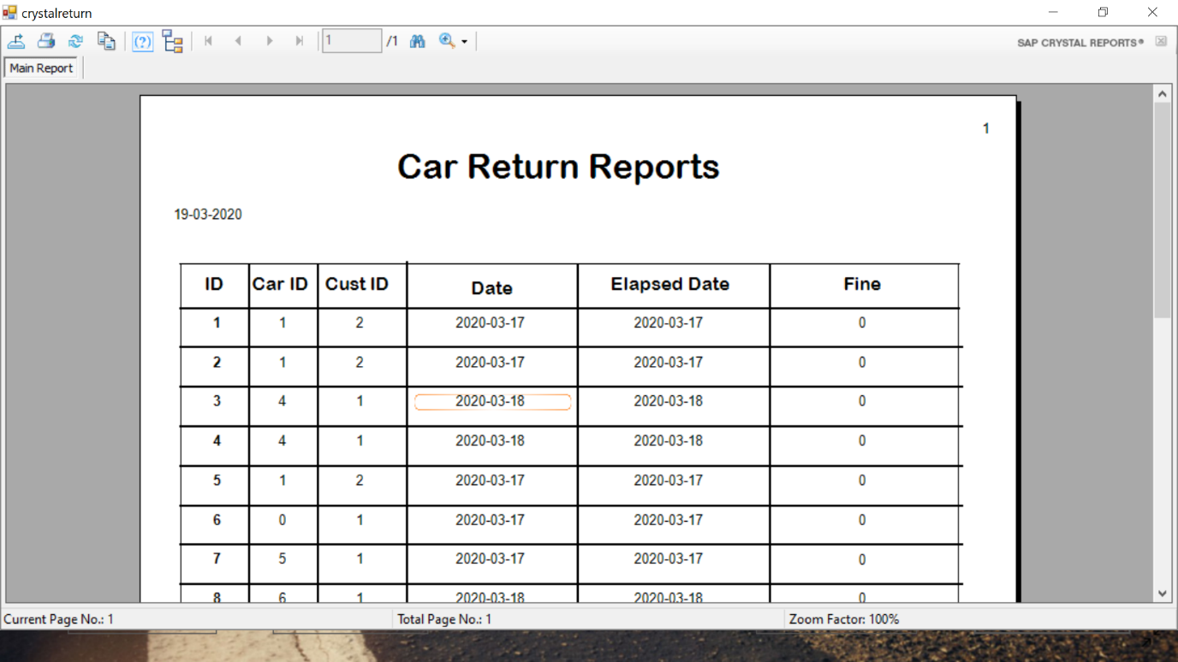

**Conclusion and Scope**

System helps to store all the data about the Cars , Customers , Rentals , Returns car details there is no need to do paper work . Data is going to be preserved carefully for longer period hence proper backup is required otherwise there is chance to losing data.

There are also chances that calculation error can occur which can cause huge problem.

Daily functions like car registration, customer registration, managing rental and return management of various departments can be easily performed with higher accuracy after the installation of ‘Car Rental System Software’.

The modules of Car Rental management software are user-friendly and easy to access. It has a common user friendly interface having admin modules. The officials can utilize these modules in their processes without any hassle and make the best possible use of Car Rental System.